Gaming-Bets

Version 1.0

Revision History

|  |  |  |  |
| --- | --- | --- | --- |
| **Date** | **Version** | **Description** | **Author** |
| 25.10.2015 | 1.0 | Basic Information | Felix Morsbach |

Table of Contents

1. Use-Case Name 4

1.1 Brief Description 4

2. Flow of Events 4

2.1 Basic Flow 4

2.2 Alternative Flows 5

2.2.1 Ticket can not reach server 5

3. Special Requirements 5

4. Preconditions 5

4.1 App started 5

4.2 Internet Connection 5

4.3 Response possibility 5

5. Postconditions 5

5.1 Notification if feedback is successfully submitted 5

6. Extension Points 5

# Use-Case Name

## Brief Description

This Use-Case will provide the possibility to check the current Leaderboard with all players listed according to their Score.

# Flow of Events

## Basic Flow

## C:\Users\Felix Morsbach\Documents\GitHub\documents\Use Case\Check Leaderboard\Check Leaderboard.png

This may not be the final version, for current version check [here](https://github.com/GamingBets/documents/blob/master/Use%20Case/Check%20Leaderboard/Check%20Leaderboard.png):

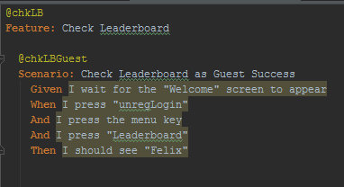

This may not be the final version, for current version check [here](https://github.com/GamingBets/documents/blob/master/Use%20Case/Check%20Leaderboard/Feature%20File.PNG):

## Alternative Flows

### Cannot reach server

If the application cannot reach the server, the user will be notified if possible via app. He will be asked to try it again later.

# Special Requirements

n/a

# Preconditions

## App started

The app must be running.

## Internet Connection

To submit feedback or a message, an internet connection is necessary.

# Postconditions

n/a

# Extension Points

n/a